Document Information

1. Document Details

|  |  |
| --- | --- |
| Title: | Accounts Payable Procedure |
| Author(s): |  |
| Version No.: | 2 |
| Status: | Approved |

1. Revision History

|  |  |  |  |
| --- | --- | --- | --- |
| Version Number | Revision Date | Summary of Changes | Changes tracked? |
| 1.00 | 04/04/22 | Approved by ARC |  |
| 2.00 | 19/06/23 | Update re change to OGP limits & amend Sole Supplier Justification Form in Appendix 3 to include procurement sign-off | Yes |
| 3.00 | 28/02/2024 | Updated for new procedures relating to Supplier set ups and quotes | Yes |

1. Approvals

This document has been approved by following approvals (in order where applicable):

|  |  |  |
| --- | --- | --- |
| **Name** | **Date** | **Details of Approval Required** |
| TUS Audit and Risk Committee | 04/04/22 |  |
| TUS Governing Body | 19/06/23 | GB advised of changes to OGP limits |

#### Purpose and scope

The objective of the TUS accounts payable policies and procedures are to ensure that:

* Purchase commitments are entered into on the basis of appropriate authorisations and budgets.
* Adequate records of purchase commitments are maintained and are fully compliant with TUS Purchasing and Procurement Regulations
* TUS receive the goods/services they order in good condition.
* Invoices and related documentation are checked and approved before being entered as creditors.
* All transactions relating to creditors are accurately recorded in the accounting records.
* Tax Clearance Procedures are complied with.
* Late Payment and Compensation Legislation is complied with.

1. **The Office of Government Procurement**

Procurement is a key element of the Government’s Public Service Reform agenda and is a very significant portion of overall spending. The Office of Government Procurement (OGP) is a business unit of the Department of Public Expenditure and Reform. It provides a central procurement service involving the organisation of procurement across a number of strategic markets thus ensuring that the Public Service operates in a co-ordinated and efficient way and delivers sustainable savings for the taxpayer.

The OGP commenced operations in 2014 and, together with four key sectors (Health, Defense, Education and Local Government), has responsibility for sourcing goods and services on behalf of the Public Service. In addition, the OGP has responsibility for procurement policy and procedures.

Public bodies are required to utilise central contracts put in place by the OGP and/or the EPS, where available, when procuring a range of commonly acquired goods and services.

To ensure TUS obtains value for money, and adheres to public procurement guidelines, it has adopted the following procedure for the purchase of all goods and services, where a central contract is not available.

#### Purchase Requisitions

TUS uses Agresso financial software to facilitate and control purchases. The purchases process generally starts with a purchase requisition.

Requisitions cannot be raised if there are insufficient funds in the departmental budget/project code to cover the purchase. Budgets are controlled by the Finance Manager, in consultation with the VP Finance and Corporate Governance, based on the annual Budget approved by the TUS Finance Committee, TUS Governing Body and the HEA.

Requisitions are raised by the appointed technician or administrator, approved by the budget holder and reviewed by Finance staff. When the approval/checking process is complete, requisitions are converted to purchase orders and e-mailed to suppliers directly from the Agresso system. Requisitions that have not completed the process cannot be converted to a PO, and cannot be printed or e-mailed to suppliers.

Appropriate segregation of duties exists with respect to the order entry process and payment. Those responsible for approving and disbursing payments do not raise orders or create GRNs. This is a critical component of the system of internal control.

#### Raising and Approving a Requisition

All requisitions are raised on the Agresso Financial Management System, and approved electronically via an automated workflow (see Appendix 1). Quotations and other documents are uploaded into Agresso and attached to the requisition, where they are available for scrutiny by budget-holders, Finance staff, auditors and other authorised parties.

Before creating a requisition, the requisitioner must have obtained quotations from appropriate suppliers, in line with the policy below. If the chosen supplier is not set-up on Agresso, a Supplier Request form is submitted to [purchasing@tus.ie](mailto:purchasing@tus.ie) – See Section 10. The supplier will be set up on Agresso to allow the requisition to be raised and recorded on the correct supplier account.

In respect of Goods and Services the following documentation must be provided:

* If the item to be purchased is less than €5,000, excluding VAT:
* One written quotation must be attached.
* If the item is between €5,000 and €24,999, excluding VAT:
  + Written quotations received from at least three suppliers
  + Relevant specifications for the job and drawings if appropriate
  + Supplier Justification Form if there are less than three written quotes, together with evidence of Requests for Quotations that were sent and the responses received, where appropriate.
  + A written explanation, if the lowest price quotation isn’t accepted.
* If the item is between €25,000 and €49,999, excluding VAT:
  + Evidence that the Procurement Office was contacted to coordinate a Request for Quotes process.
  + Written quotations received from at least three suppliers.
  + Relevant specifications for the job and drawings if appropriate.
  + Supplier Justification Form if there are less than three written quotes.
  + A written explanation, if the lowest price quotation isn’t accepted.
* If the item is €50,000 or over, excluding VAT:
* The relevant section of the tender documentation or framework agreement must be attached clearly outlining the price to be included on the order.

Quotations may be in the form of a formal quotation letter, an e-mail from the supplier or other appropriate written form. A priced basket of goods from an online supplier may be accepted at the discretion of the Finance Manager if the price is fixed and no other quote can be obtained. The quotations must be recent and/or within the validity period specified by the supplier. All quotations must state:

* Supplier name and quotation date
* Full description of the goods or services to be supplied
* The currency in which the supplier expects payment.
* Total cost before VAT and after VAT. Note: for goods purchased from outside the State, the quotation should not include VAT.

**Expiry times for supplier quotations**

* Supplier quotations are valid until the specified expiry date.  This can vary from 1 week to 3 months.
* Where no expiry date is specified, TUS will assume a validity period of 30 days.

Users are advised to ask the supplier to note the date of expiry on the quotation to avoid any doubt, especially where the purchasing process may take longer than 30 days.

In the case of all works to be carried out on site, the supplier is required to have the necessary insurance cover in place. They must also submit a copy of their health and safety statement to the Estates Department prior to work commencing.

When the requisition has been raised and documents are attached, it is sent to the budget holder for approval, via Agresso’s workflow system. The approver can view the details of the requisition and the documents attached, and either approve or reject the requisition. Rejected items are routed back to the staff member who raised the requisition for amendment or cancellation, as advised by the comments of the budget holder.

Once the requisition has been approved by the Budget holder it routs to the Finance Department for review, to ensure compliance with tax law (VAT, professional services withholding tax and subcontractor’s tax), other Revenue regulations including those relating to travel, entertaining and hospitality, and TUS policies. The Finance Team will also confirm the coding is correct. This is a two-step process, with preliminary checks by a member of the AP team and a final review by the Accounts Payable Supervisor in the Midlands or Midwest office.

Fully approved and checked requisitions are converted to a purchase order. Most purchase orders are automatically e-mailed to the supplier by Agresso. The requisitioner is notified of the purchase order number and the e-mail address to which the order was sent, via an automatic alert. If the e-mail address is missing or incorrect, it is the responsibility of the requisitioner to ensure the purchase order is delivered to the supplier.

**Automated Alerts from Agresso to identify large items and high-volume suppliers**

Budget holders (usually Heads of Department or Heads of Function) are the sole approver on requisitions. However, details of purchase orders raised each week are sent to Senior Managers, to ensure they are aware of all large orders in their area of control. The following automated alerts are sent weekly:

1. A list of all purchase orders greater than €10,000 before VAT is sent to each Dean and Vice-President. Each Dean or Vice-President will only see orders for their area of control.
2. A list of all purchase orders greater than €10,000 before VAT is sent to the Finance Managers.
3. A list of all purchase orders greater than €25,000 before VAT is sent to the Vice-President Finance and Corporate Governance. This list shows all very large purchase orders from across TUS.

In addition, an alert in relation of high-volume suppliers is sent:

1. A list of suppliers who have passed the €25,000 threshold for spend plus commitment (before VAT) in the calendar year to date. This is sent to the Accounts Payable Supervisors, Finance Managers and Procurement staff.
2. **Invoices with no purchase order**

Generally, Accounts Payable do not accept invoices without a valid purchase order number. However, the following exceptions apply where a purchase order is not required:

* Utility bills,
* Hospitality from the TUS subsidiary company,
* Local Authority rates,
* Other limited circumstances.
  + - * + **Low value, ongoing items e.g. gas cylinder rental, travel agent management fee.**
        + **Sundry items that did not require a PO in the legacy IoTs e.g. waste, insurance, legal fees. See the IoT policies for full details. TUS is committed to changing the business process to require POs to be raised for such items over the course of the first year of operations.**

1. **Goods Received Processing**

***TUS Midwest***

* The Caretakers Office acts as an interim good’s inward depot.
* The supplier provides a delivery note to the caretaker upon arrival of goods. The caretakers signs the delivery note to confirm receipt of goods; one copy is given to the supplier’s courier, and one is retained by the caretaker.
* The caretakers contact the Finance Office with the purchase order number. The Finance Office inform the caretaker who ordered the goods and they are brought to the relevant staff member.
* A Goods Received Note (GRN) is created on Agresso by the staff member who placed the order. The signed delivery note is retained in the department from which the goods were ordered.

***TUS Midlands***

Generally, goods are delivered to the Goods In Dept Athlone (Midlands Campus). The goods are accepted by a Goods In Clerk. The clerk identifies the staff member who ordered the goods from Agresso, and advises them to collect the goods from Goods In. The technician or person who placed the order checks the goods and signs the delivery docket or a printed GRN from Agresso where there is no other suitable delivery docket. The signed delivery docket is retained in Goods In. The Goods In Clerk creates the GRN on Agresso.

* Perishable goods are delivered directly to the department that ordered the goods (e.g. food ordered by the Department of Hotel, Leisure and Tourism (HTL) is delivered directly to the HTL kitchens).
* Library books are delivered directly to the Library and photocopying paper is delivered to the Reprographics Office, the Open Access Area and the Library.
* Hazardous or heavy load goods are delivered direct to the Department/Faculty where the delivery is inspected by the requisitioner. The relevant Department will then open the goods, inspect them and check the delivery docket

In each case, the signed delivery docket is brought to Goods In, and the Goods In Clerk creates the GRN on Agresso.

1. **Invoices**

#### All invoices are emailed to [accountspayable@tus.ie](mailto:accountspayable@tus.ie) by the Supplier, or by the TUS staff member who received the invoice directly. Accounts Payable will reject invoices for the following reasons:

#### • Quoting a requisition number instead of a purchase order number.

#### • No purchase order number

#### • Invalid purchase order number

#### Invoices are scanned into Agresso and indexed by Accounts Payable staff. The invoices on the register are in a holding area, and are not yet visible on the supplier account. The index includes the supplier number, invoice number, purchase order number when available, brief description and value of the invoice.

#### Indexed invoices are reviewed by Accounts Payable staff and matched to the purchase order/GRN if possible. The invoice is now visible on the supplier account as an unapproved item. The invoice then enters the Incoming Invoice workflow (see section 8 for a description of the workflow and Appendix 2 for the Incoming Invoice Workflow diagram).

#### When the invoice has successfully completed the workflow approval process, it is marked as approved for payment. The invoice will be paid on the next payment run when the due date matches the parameters of the run.

Items rejected during workflow are routed back to Accounts Payable, who raise the query with the supplier and seek the appropriate credit note.

#### Incoming Invoices Workflow Process

Invoice copies are uploaded to Agresso and attached to the transaction, together with any other required documentation e.g. withholding tax certificates, or details of changes to costs. The documents are available to requisitioners, budget holders, Finance staff, auditors and other authorised persons.

***Goods Invoices***

Goods invoices are also known as 3-Way Invoices. A Goods Received Note (GRN) is required to allow processing.

* If there is no GRN, the invoice is sent to the appropriate person (see Appendix 1) who will create the GRN if the goods have been received in good condition, or reject the task if not.
* When the GRN is complete, if the invoice matches the purchase order in relation to quantity and price, the invoice is deemed fully approved and allowed to proceed for payment.
* If there is a mismatch between the invoice and the purchase order, the invoice is sent to the Requisitioner for checking and on to the Budget Holder for approval of the additional costs. Approved invoices are reviewed by the Accounts Payable Supervisor to monitor exceptions where the purchasing rules may have been breached. When all checks are complete, the invoice is allowed to proceed for payment.

***Services Invoices***

Services invoices are also known as 2-Way Invoices. No goods are delivered, so there is no GRN. All services invoices must be approved by the Budget Holder to confirm the service was received and of acceptable quality.

* Service invoices that match the purchase order are sent to the purchase order requisitioner for checking and on to the Budget holder for approval to confirm the service was received. The invoice is then allowed to proceed for payment.
* Service invoices that do not match the purchase order are clearly identified, and the value of the additional cost is highlighted. The invoice is sent to the requisitioner for checking and onto the Budget holder for approval to confirm the service was received and to approve/reject the additional costs. Following approval, invoices are reviewed by the Accounts Payable Supervisor to monitor exceptions where the purchasing rules may have been breached.

#### Late Payment and Compensation Legislation

The Prompt Payments Act requires TUS to pay interest on invoices that are not paid within 30 days from the date of invoice receipt or receipt of the goods, whichever is later. Please refer to the Prompt Payments Act for the relevant interest rate. The current Late Payment rate is 11.15%. Compensation payments are based on the invoice value. Current payments are given below:

|  |  |
| --- | --- |
| **Amount of late payment (i.e. invoice value)** | **Compensation** |
| Not exceeding €1000 | €40 |
| Exceeding €1000 but not exceeding €10,000 | €70 |
| Exceeding €10,000 | €100 |

#### New Supplier Accounts

Staff should consider whether a New Supplier is necessary.  As the time and risk in setting up and maintaining Supplier accounts is significant, using existing Suppliers is the preferred option when cost and quality are comparable.

* Requests to create New Supplier Accounts should be directed to [Purchasing@tus.ie](mailto:Purchasing@tus.ie).  Supplier Request From available on the Finance Forms on My Apps [myapps.microsoft.com/](https://myapps.microsoft.com/)
* Finance will contact the supplier directly to obtain their full details.
* It is important that the relevant communications are initiated and monitored by Finance.

**Amendments to Existing Supplier Details**

* All requests in relation to the Amendment of Supplier Details should be directed to [Purchasing@tus.ie](mailto:Purchasing@tus.ie).
* Finance will confirm the details directly with the supplier.
* If is important that the relevant communications are initiated and monitored by Finance.

#### Supplier Payments

Before commencing a payment run, Finance contacts Revenue online and uploads updated tax clearance certificates for all suppliers into Agresso. Tax Clearance Certificates are required for all suppliers with activity in excess of €10,000 per annum. Agresso will not allow payments to be made to suppliers in breach of this criterion. In addition, requisitions cannot be raised on Agresso for any supplier in this activity band without a valid tax clearance certificate.

When ready to commence a payment run, a creditor payment report is run on Agresso. Accounts Payable validate all invoices appearing on the report and check that the invoice number and values match the payment report.

Accounts Payable run a remittance proposal report which lists all invoices that are due for payment before the due date specified. The Accounts Payable Supervisor checks the remittance proposal and if satisfied, signs off the report.

A tax deduction report (TX01) is generated. TX01 applies prompt payment interest, late payment compensation, withholding tax and relevant contract tax to the planned payments. In addition, the process removes any suppliers with year-to-date expenditure in excess of €10,000 who have not provided a valid Tax Clearance Certificate from the payment run. The TX01 is reviewed in detail by Accounts Payable staff to confirm Revenue and OGP regulations are met.

Accounts Payable then run the final remittance report. The report is approved by the Finance Manager or their nominee prior to payment.

Payment is made via electronic transfer of funds (EFT). Accounts Payable ensure that sufficient funds are available to meet the payment run. Accounts Payable then create a bank file. The file is uploaded onto the Bank of Ireland File Gateway system by the Accounts Payable Supervisor and approved in accordance with the bank mandate,

Accounts Payable generate remittance advices, which are e-mailed to suppliers directly from Agresso.

TUS does not issue payments by cheque.

#### Supplier Statements

Supplier statements are reviewed as they are received for older items that may indicate missed invoices. A sample of statements, as selected by the Finance Manager, is fully reconciled each month. A more-detailed reconciliation is undertaken once per year, with all available statements reconciled. Missing statements for significant accounts are requested. All differences are investigated and resolved in a timely manner.

#### Foreign Payments

Payments to foreign suppliers are processed through a secured internet payment system, known as “Fexco”. The process for foreign payments is the same as above. Once the final remittance report is authorised, the Accounts Payable Supervisor exports the file to Fexco.com. The supplier and payment details are entered on the system and the payment is approved in accordance with the bank mandate.

1. **Student Refunds and Payments to Students**

The Finance Department issues refunds due to students, at the written request of the Student Fees Administrator and the appropriate manager.

Other payments to students (e.g. Student Assistance Fund, Childcare Payments, Erasmus, Scholarships) are approved in a similar way by the appropriate manager.

A list of students with their bank details is sent to Finance. The list is uploaded into Agresso, using the sundry student payment account on the creditors’ ledger. The payment process is completed as above.

#### Appendix 1 – Purchase Requisition Workflow

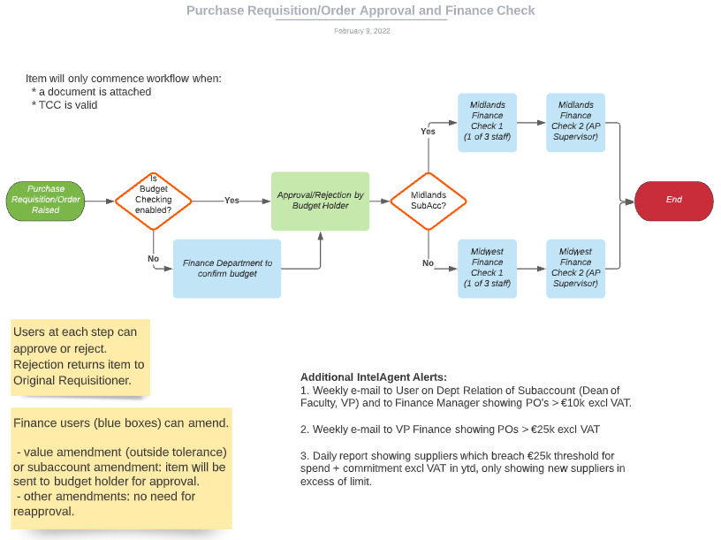

**Appendix 2 – Incoming Invoice Workflow**

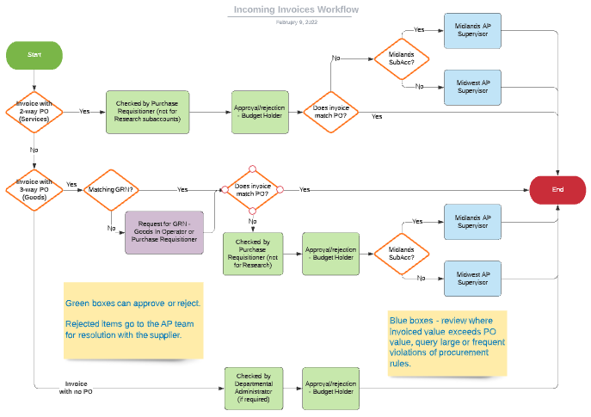

**Appendix 3 – Supplier Justification Form**

**Appendix 4 – New Supplier Request Form**

