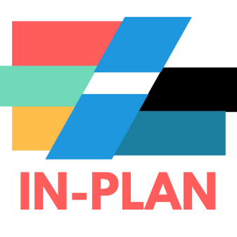
IN-PLAN: Integrated climate, energy and spatial plans
Technological University of the Shannon (TUS) has begun participating in a new EU funded project looking at developing and implementing energy plans in local and regional authorities. The kick-off meeting was held recently in Zagreb, Croatia and was attended by development unit senior project officer Dr Darren Barry. The project will run until March 2026.
The overarching objective of IN-PLAN (Integrated Energy, Climate and Spatial planning) is to develop, test and roll out the IN-PLAN practice – a long-lasting support structure enabling local and regional authorities to effectively implement their sustainable energy, climate, and spatial plans. They aim to do so by:
- Integrating energy and climate planning with spatial planning (and other types of planning tools, such as mobility, infrastructure, etc.);
- Ensuring commitment at all political levels (through vertical integration); and
- Matching the included measures with specific dedicated local and regional budget lines.
On top of delivering this innovative and effective approach, IN-PLAN intends to empower local and regional governments and their agencies through a two-step capacity-building programme. From the start, the IN-PLAN consortium will engage 15 local and regional governments – the Lighthouses – in order to co-create, implement and refine the IN-PLAN practice, its operational guidelines and the capacity-building programme. 30 more local and regional governments – the Pilots – will also benefit, in part, from the IN-PLAN practice.
Once developed, the two-step capacity building will start. Phase one will aim at training the trainers: empowering energy, climate and/or development agencies from across Europe to become IN-PLAN Multipliers. Phase two will aim at passing on the knowledge to local and regional governments, the Replicators. They will be tutored either by the five national project partners or by the trained multipliers.
IN-PLAN’s ultimate goal is to empower local and regional authorities in developing and implementing integrated energy, climate, and spatial planning in their territories.
Follow #LifeINPLAN on every channel!

