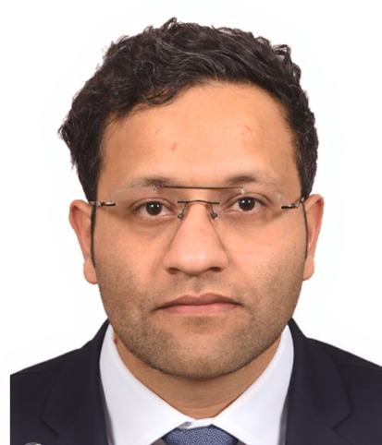 |  | AKSHAY JASSAL  Research Scholar
Profile  As a dedicated Research Scholar, I am currently working on the development of a novel method for microplastic pollution detection in the Shannon River area, integrating advanced spectroscopic techniques and modern machine learning models. My focus is on building a reliable dataset through experimentation and material Characterisation, followed by applying machine learning algorithms to identify, classify, and quantify microplastic particles in complex samples.  Contact  Email- akshay.jassal@tus.ie  +353894318197  LinkedIn- linkedin.com/feed/update/share:7369702343254224897/  Address: 56, Cronan Lawn, County Clare, Shannon, V14 X997  Skills  - Advanced material Characterisation techniques: Scanning Electron Microscopy (SEM), Fourier Transform Infrared Spectroscopy (FTIR), and Raman Spectroscopy.  - SolidWorks  - Ansys  - Python |  | EDUCATION  Technological University of Shannon (TUS), Moylish  Campus (Ireland)  Research Master [August 2025 – Pursuing]  - Development of a novel method for microplastic pollution detection in the Shannon River area using spectroscopy and modern machine learning techniques.  Indian Institute of Technology (IIT), Kharagpur (India)  Master of Technology Specialisation in Mechanical System Design [July 2016]  - Investigated the non-linear vibration characteristics of a freedom rubber support system.  Indian Institute of Technology (IIT), Kharagpur (India)  Bachelor of Technology (Mechanical Engineering) [July 2014]  - Developed a multilayered smart structure on a cantilever beam and analysed it using a micromechanical model, and first-order shear deformation theory has been used to investigate the behaviour of a negative Poisson’s ratio material layer.  WORK EXPERIENCE  TUS [Research Assistant]  [Aug 2025–Current]  [Ruckcus Innovus Limited, Ireland]  Faculty  April 2018-December 2024  [Mechanical Engineering Department, Gate Revolution Pvt, Ltd., Chandigarh, India]  Achievements  - Qualified Graduate Aptitude Test in Engineering (GATE) with an All-India Rank (AIR) 111.  - Qualified Union Public Services (UPSC) Engineering Services Examination.  - Secured AIR 440 in IIT JEE 2010.  - Secured AIR 552 in AIEEE 2010.

