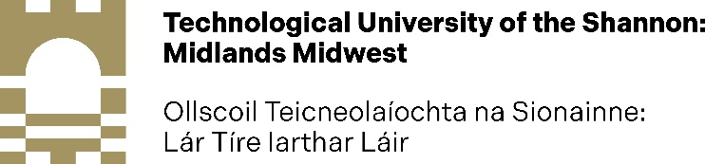

GS12: DECLARATION OF NO CONFLICT OF INTEREST 2023-2026
When Internal and External Examiner(s) are being nominated, due cognisance should be taken of any potential conflicts of interest (COI), including those of a personal or professional nature (or both).

The term ‘conflict of interest’ is defined as a situation in which someone cannot or is potentially compromised in making a fair decision because they will be affected by the result’ and as ‘compromise of a person’s objectivity when that person has a vested interest in the outcome of a study.

COI occurs when the person could benefit financially or in other ways (e.g., promotion, prestige) from some aspect of a study, report, or other professional activity. However, the person may not actually benefit financially or otherwise from the result. COIs can emerge from bias (which can be conscious or unconscious).

The completed form, signed and dated, should be emailed to
Midwest Limerick: graduatestudies@tus.ie or Midlands Athlone: gsr@tus.ie

Section A: To be completed by the proposed internal/external examiner
Name
Institutional Affiliation
Institutional Address
Name of Research Student
Faculty and Department
Date and Location of Proposed Viva

Section B - Declaration and Signature by Proposed Examiner

I confirm that there is no conflict of interest which could compromise the conduct of this viva examination and/or the result.

Signed:
Print Name
Date

