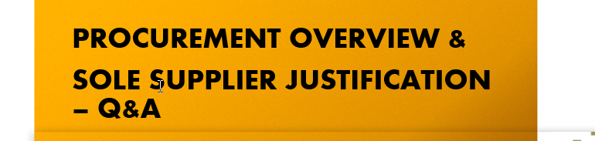
Slide 2 Procurement Thresholds
Quote request - >€5,000 ≤ €25,000
- It’s a lighter, quicker process than a full tender (for example: email requesting pricing/other requirements)
- The buyer sends a short description of what they need (the product/service, quantity, delivery, etc.). Ensure that a response deadline is included in the quote request to all parties.
- Suppliers reply with their prices and terms.
- The buyer compares the quotes and chooses the supplier that offers the best value (not always just the cheapest).
- The process must be fair, transparent, and documented.
- All quotes received (minimum 3) should be uploaded to Agresso with the PO requisition. If the preferred supplier did not submit the lowest value quote, then a short note outlining the basis for the selection should also be uploaded

