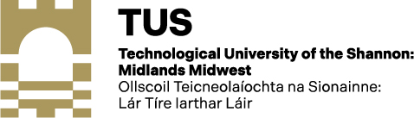

BIKE TO WORK SCHEME

DECLARATION FORM

I confirm that the bicycle and equipment being purchased by Technological University of the Shannon: Midlands Midwest on my behalf under the
“Bike to Work Scheme”, is for my own use, and will be used mainly for qualifying journeys i.e. whole or part (e.g. between home and train station) of a journey to the Institute.

Please indicate if you have availed of this scheme in the last five years:
Yes No

Signed: _______________________ Date: _______________

