AGRESSO GUIDE
PURCHASING PROCESS AND REQUISITIONERS TASKS

Purchase Approval Process

- User raises a requisition which must have a valid quote attached.

- Budget Holder Approves Requisition

- Finance Check – To review quote/back up and coding

- Finance Approval – Final review

- Approved Requisition is converted to a Purchase Order.
Supplier will receive a system generated email with the PO Number
The Requisitioner (you) will receive an email to advise of the PO number. Confirm that the supplier email used is correct – this detail is on the email from Agresso.
PO number to be used on invoices for payment (the requisition number is not accepted)

- The Supplier emails their Invoice to AccountsPayable@tus.ie ensuring the TUS Purchase Order Number is quoted on the invoice.

- The Invoice is registered by a member of the Accounts Payable Team and goes to workflow for approval.

Requisition Tasks

You will receive an email from Agresso_DoNotReply@tus.ie alerting you that there is a new item in your task list.

Quote Required – attached a valid quote to the Requisition and select Save

Requisition Review – a Requisition has been returned to you for amendment.
Go to Requisition details – Select the rejected line which will open the Workflow log and allow you to view the comment which will provide detail on the amendment required.
Apply required amendments and select Save to send the Requisition back for approval.

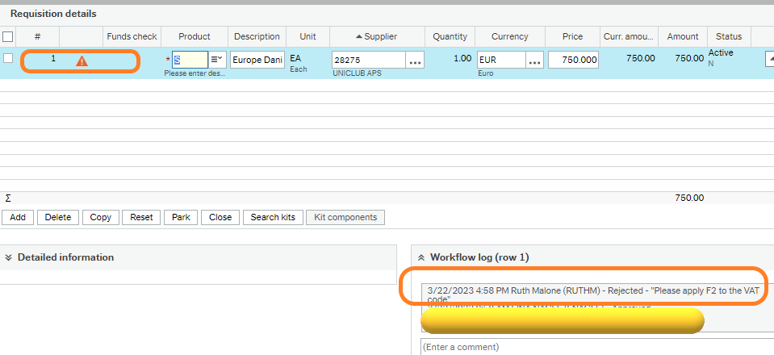

Invoice Approval Process

You will receive an email from Agresso_DoNotReply@tus.ie alerting you that there is a new item in your task list.

- Service Invoice (matches PO) - sent to Requisitioner for detailed checking and then to Budget Holder to confirm the service was properly delivered.
Accept or Approve if OK pay. Reject if not.

- Goods Invoice (exceeds PO) / Service Invoice (exceeds PO) - sent to Requisitioner for detailed checking and then to Budget Holder for approval. There are additional costs or higher prices than expected. The Order Lines box Shows the order quantities and invoice quantities for comparison.
Accept or Approve if OK to pay. Reject if not.

- Missing GRN (Midwest Staff Only) – Invoice has been received but Goods have not been confirmed as Delivered. Please refer to Goods Received Notes to complete a GRN. GRNs should be generated when Goods have been received so this type task should not appear often.
Accept or Approve if OK to pay. Reject if not.

The Order Lines boxes show the order quantities and invoice quantities for comparison.
Accept if OK to pay. Reject if not.
Approve
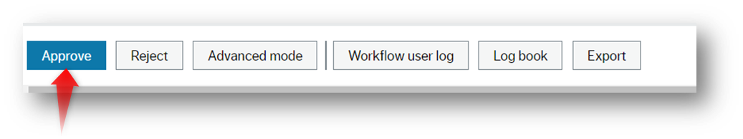
Reject
The approver can reject a task but must enter a comment. The item will route back to the Requisitioner or to Finance for amendment/closing.
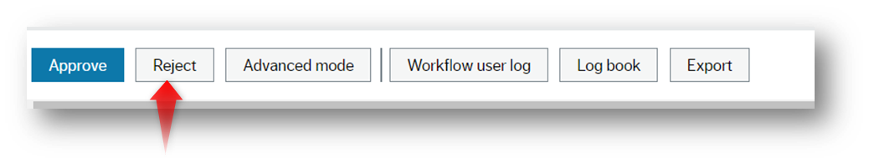
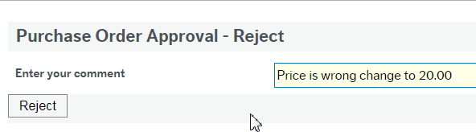

Accounts Payable

- If the approval process is completed with no delay – it should make the next payment run.
- Payment dates cannot be provided until the approval process has been fully completed
- Payment runs are generated weekly by the Accounts Payable Team

