AGRESSO GUIDE
ACTIVATING A SUBSTITUTE

Setting up a substitute

- If you are going to be absent and would like to assign a Substitute to deal with your tasks in your absence, you can do so by Activating a Substitute

- If it is the first time this individual is going to be your substitute, you will have to email AgressoSupport@TUS.ie and request this user be added to your substitute options.
Once the user has been added you will be able to select this user as a substitute anytime going forward.

- Select your Absence status and enter dates absent. Once you choose the ‘I am currently out of office’ status, you will be able to enter to and from dates for your absence.

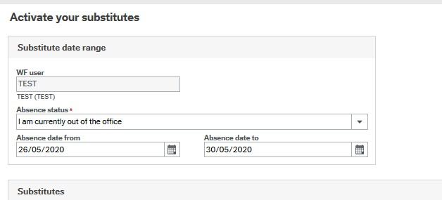

- On the lower part of the screen select 'General' under 'Type; and then select your Substitute. If you have multiple substitute options, you can select a different one from the ‘Substitute’ field. Clear the name that is there and hit the space bar. It should display all substitute options available to you.

If you have queries on the process, please email AgressoSupport@tus.ie

