AGRESSO GUIDE
REPORTS FOR BUDGET HOLDERS
Contents
1. Introduction to Web Reports 3
2. Annual Budget Report 4
3. Multi Year Budget Report 4
4. Open Purchase Orders 5
5. Open Subaccs 5
6. W31- Transaction Listings 5
7. Additional Reports 5
8. Exporting Reports 5
9. Queries 6

Introduction to Web Reports

Reports are available within the Budget Holders Workspace
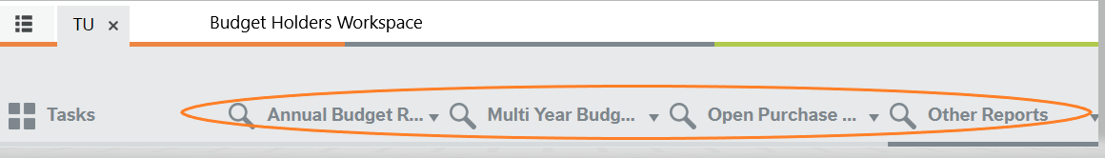
Most reports will run automatically based on your Agresso user profile.
Some reports will require some input from the user. For example, Transactions Listing Report requires the user to enter the Subacc (Dept/Project) code they want to generate the report for.
Once a report has run, you can use the filter options. These are the blank fields above the generated report. Once you have entered your filter options ie a particular Dept/Subacc/Project click on search and the report will filter accordingly.
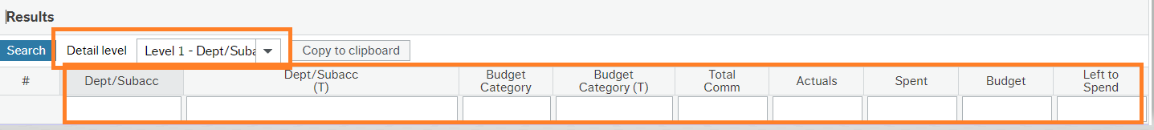

You can expand the report further by changing the detail level to Level 2 Budget Category or All Levels

Annual Budget Report

This report will show the budget and activity for your assigned Subac/Dept for the current academic year.
It is the main budget report for viewing Faculty/Department budgets.

Select the report based on your Role.

W01- Annual Budget VP/Dean
W03 – Annual Budget – Manager/Budget Holder

As outlined in the running reports section above you can filter these results using the report headings and the dropdown under the detail level.

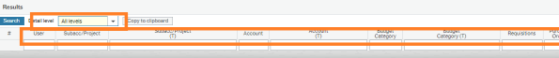

When the report is viewed at Detail level – All levels, you can drill into amounts to retrieve further detail on the expenditure including any attached documentation.

Annual Budgets are released in 3 Tranches over the course of the Academic Year:
Tranche 1 - Sept - Dec
Tranche 2 - Jan - April
Tranche 3 - May - Aug

For budget enquires contact:

For Midlands - Anna Fallon Anna.Fallon@tus.ie
For Midwest - Jennifer Sexton Jennifer.Sexton@tus.ie

Multi Year Budget Report
This report can be used to view Budgets for Projects that have Multi-Year Budgets eg Research Projects

Select Report based on your Role.

- W05- Multi Year Project VP/Dean
- W02 – Multi Year Project – Budget Holder/Manager
This report will show all budgets and transactions over the lifetime of the relevant projects to date.
When the report is viewed at Detail level – All levels, you can drill into amounts to retrieve further detail on the expenditure including any attached documentation.

Open Purchase Orders

Select Report based on your Role.

- W41- Open Orders VP/Dean
- W42 - Open POs Budget Holder/Manager
Lists all Open (Unpaid/Committed to Budget) Purchases Orders.
Search by a particular subacc.
Remove the ‘O’ entry under status to view all Purchase Orders – Open and Paid

To request that a Purchase Order be closed, please email purchasing@tus.ie

Open Subaccs

Lists all active Subaccs (Dept/Project)
Select report based on your Role

- W80 Open Subaccs Dean/VP – Lists all active codes in your Faculty/Functional area.

- W81 Open Subaccs Budget Holder/Manager – Lists all active codes where you are the budget holder assigned on Agresso

W31- Transaction Listings

Report lists all Non-Pay Transactions (paid items) for the Current Academic Year.
Enter the Subacc (Dept/Project)
The results are displayed by Budget Category, which can be expanded by clicking on + to the left of the line items.
Clicking on the transaction number will take you to the transaction details screen, which will display attached documentation ie Invoice.
Amend Period from 202301 (Sept 22) to view transactions outside the current academic year.

Additional Reports
There are some additional reports available in addition to those listed above, but are area specific.

Exporting Reports

You have the option to export the report results using the ‘Export’ button on the bottom of the screen. You can export in a number of different formats:

- Browser [.xlsx] – this will export the report results to excel in a specific browser format. Categories are summed up and can be expanded using the + on the left.
- Pivot [.xlsx] – this will export the report results to excel as a pivot table.
- Default [.xlsx] – this will export the report results to excel as plain data
- Default [.pdf] – this will export the report results to Adobe Acrobat in pdf forma

Queries
If you wish to request access to specific reports or have any further queries in relation to the web reporting facility, please email AgressoSupport@tus.ie

