TUS Moylish and Clare St. Staff Permit Applications

Step 1 : Using Google Chrome or Firefox go to:
https://tuspermit.apcoa.ie/applicant

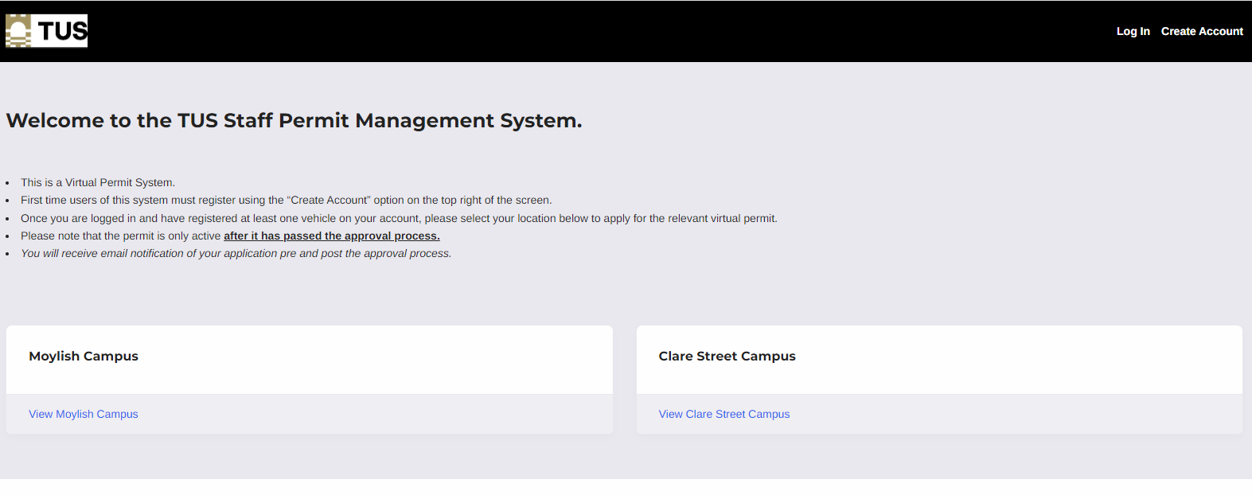

Step 2 : Login or Create New Account

Existing Users, please use the “Login” to access your account.

New Users:
Please use “Create Account”. The mandatory information required is name, TUS email address, phone number, dept (in address line 1), vehicle registration. and staff ID. Address information can be left blank or anonymised with alphanumeric characters.
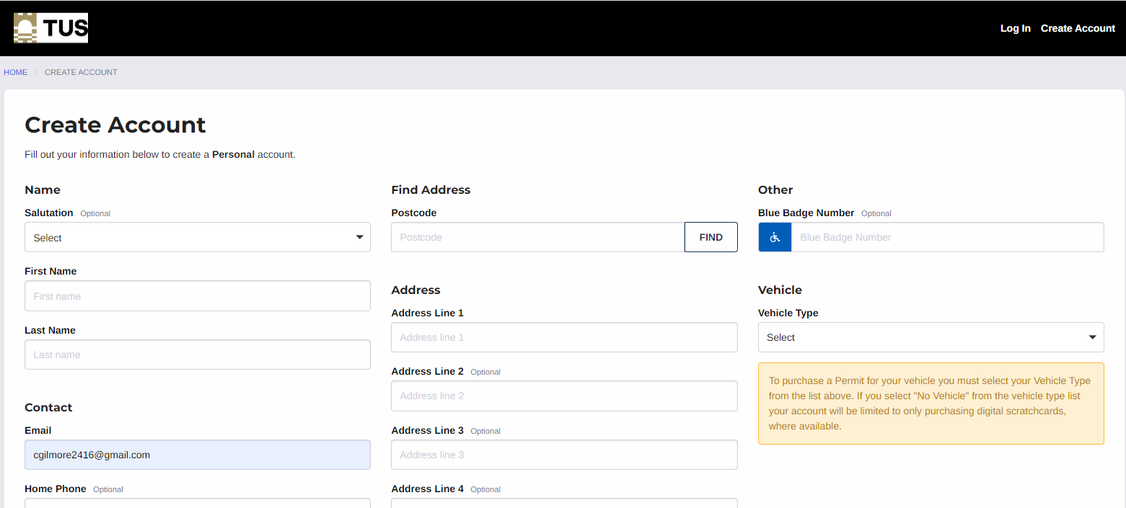
Step 3: Apply for Permit.
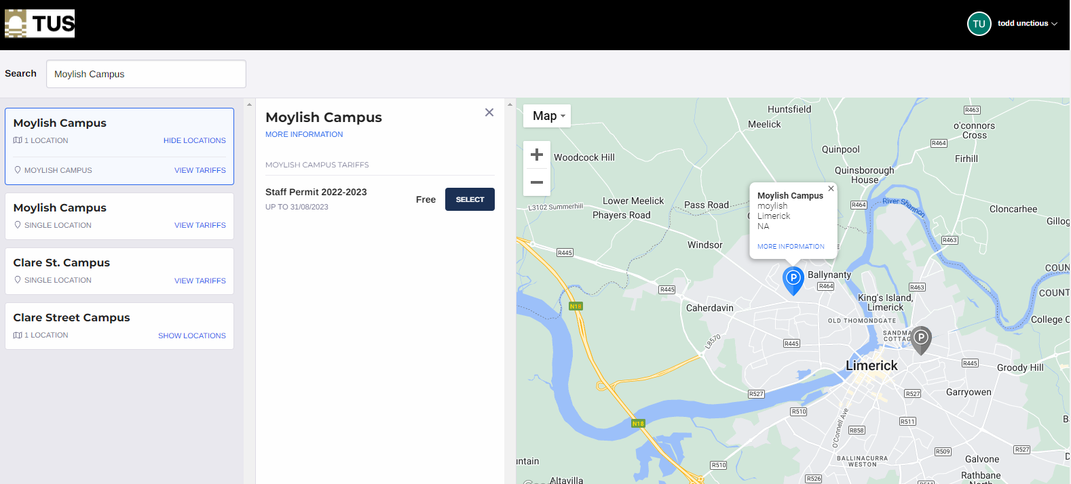
“Select Parking Period” accept “Terms and Conditions” and “Proceed”.
One permit covers both Moylish and Clare St campus.

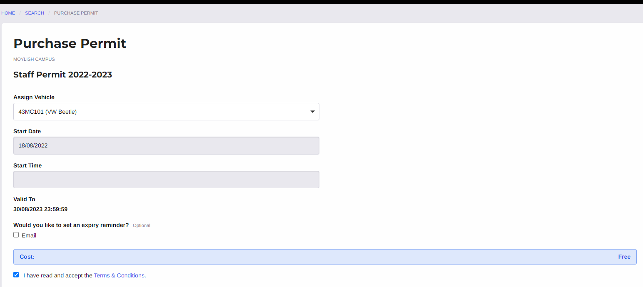
- You can further manage your account by selecting your name in the top right hand corner of the screen. Here you can manage your vehicle registrations and change protection on your permit.
- For all permit applications Vehicle Registration must be selected.
- Additional Vehicles can be added to the account using the menu on top right of screen “Vehicles”.
- Protected Vehicles can be changed by accessing the “Bookings” option on the same menu.
- You will receive emails at each stage of the application process (Permit Pending Approval, Permit Approved or Declined).
- Once your application is approved, the permit is live and the vehicle registration chosen is protected on the system.

Step 4: To raise the barrier.
The Staff ID card gives you access to the staff car parks. Scan the bar code on your ID card against the barrier. To obtain an ID card, email ITservicedesk.midwest@tus.ie attaching your photo.

