

**Visitor parking booking form**

|  |  |
| --- | --- |
| Visitor parking **requested by:** |  |

|  |  |  |  |  |  |  |
| --- | --- | --- | --- | --- | --- | --- |
| **Visitor dates** | **Arriving time** | **Departing time** | **No. of visitors** | **Visitor Name** | **Car reg** | **Email Mandatory to receive QR Code** |
|  |  |  |  |  |  |  |
|  |  |  |  |  |  |  |
|  |  |  |  |  |  |  |
|  |  |  |  |  |  |  |
|  |  |  |  |  |  |  |
|  |  |  |  |  |  |  |
|  |  |  |  |  |  |  |
|  |  |  |  |  |  |  |
|  |  |  |  |  |  |  |
|  |  |  |  |  |  |  |
|  |  |  |  |  |  |  |
|  |  |  |  |  |  |  |

Visitors will receive an email with an attachment containing a QR code. Visitors must then scan this QR code at the barrier for entry.

Please Email completed form to [estates.midwest@tus.ie](mailto:estates.midwest@tus.ie)

**Follow the red arrows to the Visitor’s car park marked no. 3 below:**

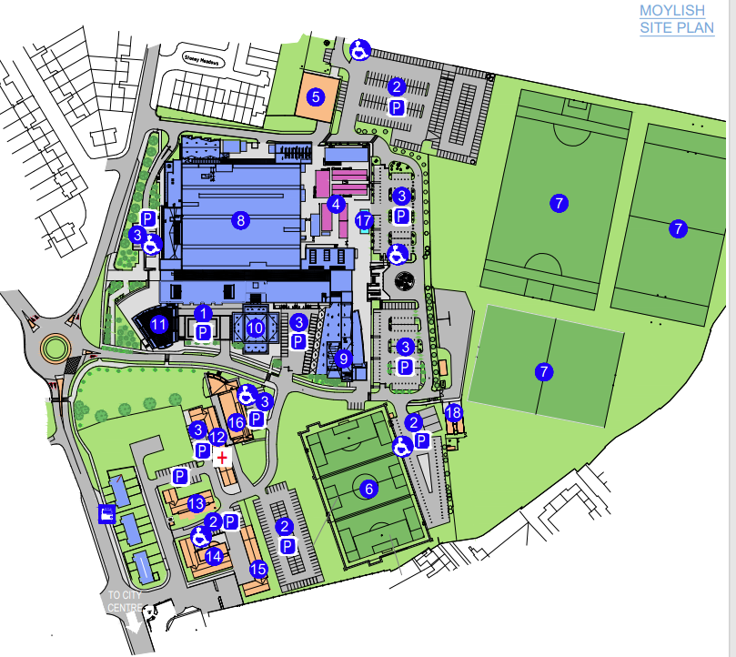

19 spaces