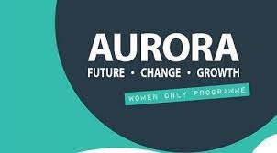
Aurora Leadership Development Programme for Women 2024/2025
The Aurora Leadership Development Programme is for female staff. Applicants should be ambitious for a career in the sector and interested in exploring leadership and management as an option for progression.
Applications must be submitted by 18th September to Dr Carol Wrenn via email to equalityanddiversity@tus.ie
SECTION 1

Name :

Job Title : | Staff Number:
Faculty/Department/Research Institute/Function: | Email address of Applicant:

The Aurora Leadership Development Programme is structured as six online Modules and one in person module hosted in Dublin. In addition, it includes a mentorship programme which involves mentorship training, and a 12 month mentorship commitment. Acceptance onto the programme requires a commitment that you will be available to attend all modules, as well as participate in the introductory webinar, mentorship training and mentorship programme.

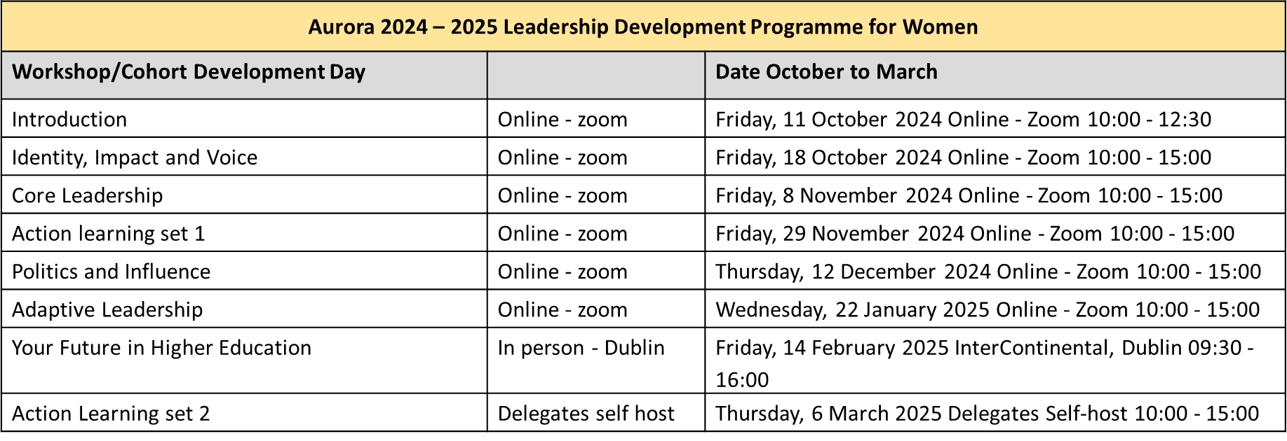

To support the Aurora programme, TUS is organising a Mentorship training for Mentors and Mentees. Details of this are as follows:

Mentee Training | Online – zoom: 9:15 – 1pm | 3rd of October
Mentor Training | Online – zoom: 9:15 – 1pm | 21st of October

If you are a selected Aurora participant, you will be encouraged to attend the mentee training, and your mentor will be invited to attend the mentor training.

I confirm that I am available to attend all workshops and trainings listed above:

Aurora Applicant (Capitals): ______________________ Signature: ___________________________

Date: ___________________________
The EDI Office will pay the participant fees for the programme. In the event that online delivery is suspended and there is requirement to travel to a face-to-face workshop, travel expenses to and from the programme venue in Ireland will be covered by the EDI Office. Supporting participation on the Aurora programme not only requires a significant cost investment by TUS, it also requires a local time investment to attend the modules and to engage in mentoring (1hr meeting per month x 12 months).

SECTION 2

Personal Statement:

Applications will be scored by the evaluation panel against the following four questions:

- What development needs and/or leadership challenges are you experiencing in your current role?
(40 marks)
- How do you perceive Aurora will support you in addressing these needs/challenges? (20 marks)
- What learning outcomes do you expect to achieve from your engagement with the Aurora programme? (20 marks)
- How do you plan to apply your experience with Aurora to the development of other colleagues? (20 marks)

Please use the space below to complete your Personal Statement.

What development needs and/or leadership challenges are you experiencing in your current role? (40 marks) Word limit: 500 words

How do you perceive Aurora will support you in addressing these needs/challenges? (20 marks)
Word limit: 250 words

What learning outcomes do you expect to achieve from your engagement with the Aurora programme?
(20 marks)
Word limit: 250 words

How do you plan to apply your experience with Aurora to the development of other colleagues? (20 marks)
Word limit: 250 words

