LIMERICK INSTITUTE

OF TECHNOLOGY

INSTITIUID TEICNEOLAIOCHTA

LUIMNIGH

MATHEMATICS ENTRANCE EXAMINATION

SAMPLE PAPER

Subject: Mathematics

Time Allowed: 2 Hours

Instructions: 1. Attempt ALL FIVE questions

2. Each question is worth 20 marks

3. Total marks available: 100 marks

4. Marks will be lost if all necessary work is not clearly shown

5. Answers that are not legible will be marked incorrect

6. Answers should include the appropriate units of measurement, where relevant.

Additional Attachments: A. Mathematics Tables

B. Graph Paper

Internal Examiner: Dr Maura Clancy

**Question 1**

(a). **(i).** The tourist rate for the Swiss franc is quoted in a newspaper as €1 = 1.90 fr.

How many francs can be purchased for €310? **(2 Marks) (ii).** A ship's crew numbers 105, of which *f* are women. Of the men, *t* are officers.

How many male officers are on board? **{2 Marks)**

**(iii). A** man buys a house and makes a 20% profit when he sells it three years later for €312000. What did he pay for it originally? **{2 Marks)**

**(iv).** Without the aid of a calculator, that is show all your workings, evaluate the following expression, taking positive square roots only.

25 *r-* 64x 3 2

"V

144 X 3

**{2 Marks)**

**(b).** The equation of the line *L* is *x* + 3y- 12 = 0. The equation of the line *K* is

*3x- y* + 14 = 0. Find the coordinates of *q,* the point of intersection of *L* and *K.*

**(4 Marks)**

(c). **(i).** Express::in the form a+ *bi.* **(4 Marks) (ii).** Let Z1 = 4- *2i* and Z2 = -2- *6i.* If Z2 - pZ1 = *qi* with *p, q* E R, find *p* and *q.* **(4 Marks)**

**{Total 20 Marks)**

Question 2

(a). (i). Solve the following inequality for *x* E R and graph your solution on the number line:

3(x- 4) > 5(2x- 3) + 17

(4 Marks)

(ii). Simplify the following expression:

(mn2)3

*(m2*1 *n4*1 )4

(2 Marks)

(iii). A pinter is paid €15.30 per hour for a basic 36 hour week and overtime is paid at one and a third times this rate. Determine how many hours the painter has to work in a week to earn €673.20. (2 Marks)

(iv). Solve the following equation for *x,* give your answer correct to one decimal place:

2 1 1

3x- 4 *2x* + 1 2

(3 Marks)

(v). Write down a quadratic equation with roots and -4.

(2 Marks)

(b). The sag *S* at the centre of a wire is given by the formula:

3d(£- *d*

S= 8

(i). Rearrange the equation to make £the subject. (3 marks)

(ii). Hence, determine the value of£ when *d* = 1.75 and *S* = 0.80.

(1 Mark)

(c). The area of a rectangle is 23.6 cm2 and its width is 3.10 em shorter than its length.

Determine the dimensions of the rectangle, correct to 3 decimal places.

(3 Marks) (Total 20 Marks)

Question 3

(a). (i). Find the equation of the line containing the point A(-6, -2) and with slope m= -5. (3 Marks)

(ii). Given the following points: P(1, 3), 0(5, 3), R(6, -4) and S(2, -4). Verify that

*P QRS* is a parallelogram by showing that opposite sides in the quadrilateral have the same slope. (4 Marks)

(iii). Find the equation of the line parallel to the y-axis and containing the point

(-2, 3). (3 Marks)

(b). *k* is the circle x2 + y2 = 17.

(i). Write down the centre and radius length of *k.*

(ii). Prove that the line t: *x* + 4y = 17 is a tangent to *k.*

(iii). Draw a sketch of *k* and *t.*

(2 Marks) (3 Marks)

(2 Marks)

(iv). £ is a second tangent to *k,* which is parallel to *t.* Find the equation of£.

(3 Marks) (Total 20 Marks)

Question 4

(a). Given that sine=

2

where 0' < *e* < 90 ; . Show that cos2 *e* + sin2 *e* = 1.

(5 Marks)

(b). In the given figure: *LPSR* = 90: , *PQ* = 10 em, *QS* = 6 em and *RQ* = 9 em.

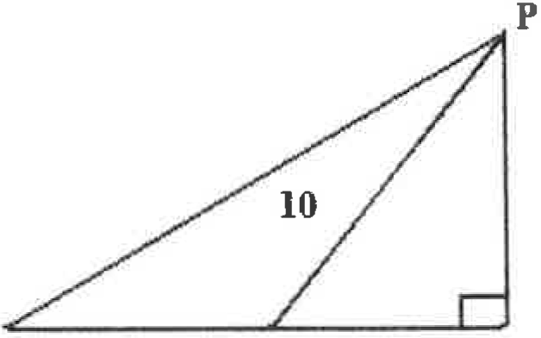Calculate the length of *PR.*

R 9 Q 6 s

(5 Marks)

(c). A radio station tower was built in two sections. From a point 87 feet from the base of the tower the angle of elevation of the top of the first section is 25 ' and the angle of elevation of the top of the second second is 40 ' . To the nearest foot what is the height of the top section of the tower?

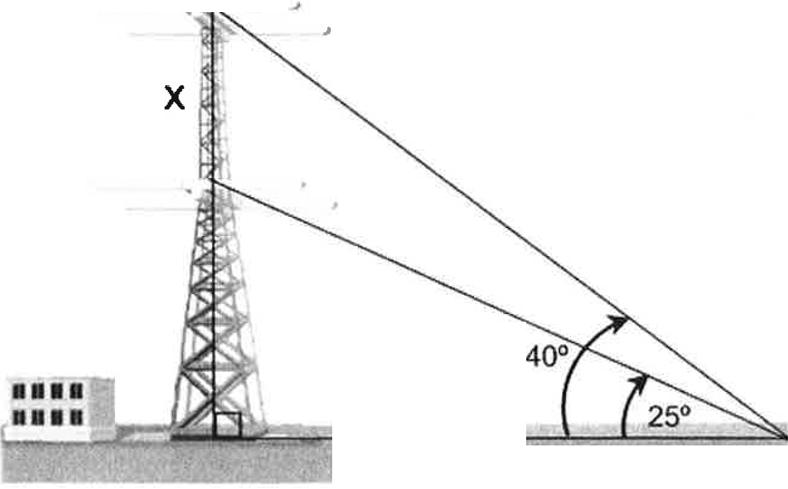

87feet

(10 Marks) (Total 20 Marks)

Question 5

(a). Considerthe word *ORIEL.*

(i). How many arrangements have the three vowels first?

(i i). In how many arrangements are the three vowels together?

(2 Marks)

(2 Marks)

(b). There are five third-year students and six fourth-year students in a running club in a school. A team of three students are to represent the school at a meeting.

(i). How many different teams are possible? (2 Marks)

(ii). In how many of these teams are there more fourth-year students than third-year students? (2 Marks)

(c). A bag contains five discs numbered 1,2,3,4 and 5. A disc is arawn from the bag and not replaced. Then a second disk is drawn from the bag. Find the probability that:

(i). the sum of the outcome is less than 5.

(ii). One outcome is exactly 3 greater than the other.

(2 Marks)

(2 Marks)

(d). At the end of a marathon eight athletes are randomly selected. All of the athletes are asked to give their age and their time (in minutes) for the race. The results are

given in the table below:

|  |  |  |  |  |  |  |  |  |
| --- | --- | --- | --- | --- | --- | --- | --- | --- |
| Age | 33 | 33 | 31 | 26 | 26 | 25 | 30 | 29 |
| Time | 132.6 | 132.1 | 133.1 | 134.0 | 134.1 | 134.6 | 133 | 133.5 |

(i). Draw a scatter graph of the data.

( i i). What is the type of correlation between the two variables?

(iii). Describe the correlation between age and time.

(2 Marks) (2 Marks)

(2 Marks)

(iv). Explain why the correlation described in part (iii) will not apply for athletes in the 54-64 age bracket. (2 Marks)

(Total 20 Marks)